What is domestic violence?
Domestic violence is a pattern of behavior one person uses to gain power and control over his or her partner in an intimate relationship. Behaviors can include intimidation, threats, psychological confusion, emotional pain, verbal abuse, physical attacks, sexual assault, and homicide.
Abusive behaviors can also include periods of apologies, blaming, little or no communication, promises to change, and gifts. By changing methods and types of abusive behaviors, the perpetrator is constantly keeping his or her partner on edge and in fear.
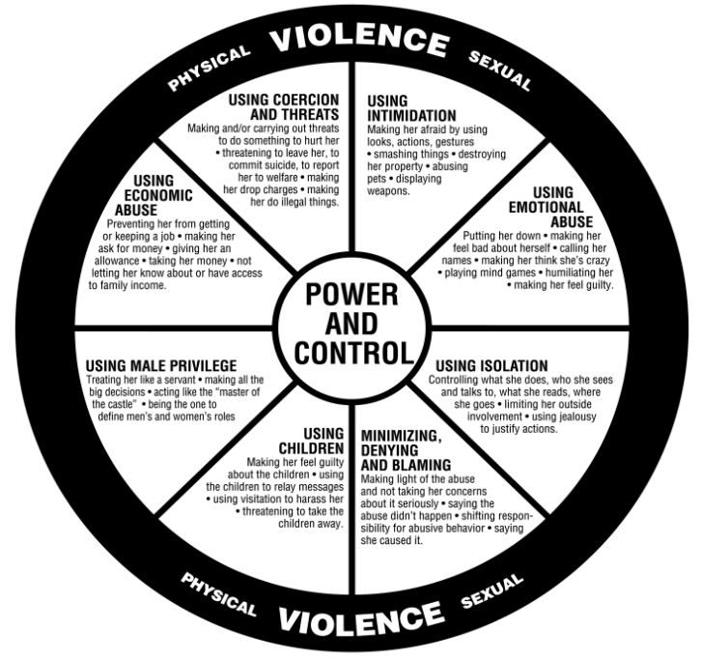
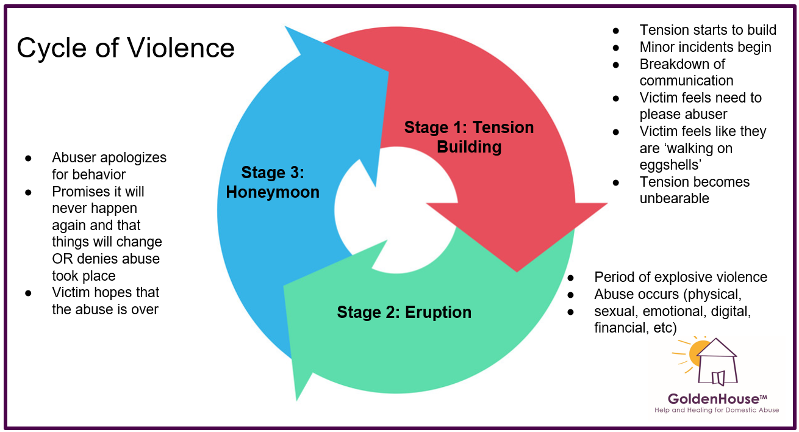

Things you can do or say when someone confides in you at work:
- Learn if they feel safe in their home. Learn if their children are safe in their home.
- Give them personal safety plan checklist and remind them that no matter what, their physical safety needs to be top of mind every day.
- Tell them that what is happening to them is real and it is wrong. (Victims often feel it is their fault or they are unworthy of being loved.) Nobody deserves to be hurt.
- Help them feel comfortable reaching out to:
  - EAP
  - Yvonne, Avery, Sara Abel
  - Golden House: 920-432-4244
It does not need to be an emergency to call Golden House, don’t hesitate to call to learn more or to ask about next steps. Once connected with Golden House, an advocate can meet with them regularly to help them know what to do next. They could meet over the phone, at a coffee shop, at Schreiber, wherever they want to…….) Golden House programs include working with people for as long as it takes (months, years). Free counseling, legal assistance, etc to help people walk through this journey.
Guidelines for things to ask / say:
Safety is the priority at all times.
Do ask…
➢ Is someone hurting you?
➢ Did someone hurt you?
➢ Are you afraid of your partner?
➢ Has your partner ever hit (kicked, hurt) you?
➢ I have a friend whose partner tries to control everything they do. Is this happening to you?
➢ Is there someone from a previous relationship who is making you feel unsafe now?
You can say…
➢ I believe you.
➢ You are not alone. There are many people who have gone through this.
➢ I care about you, and I know how hard it is to talk about this.
➢ You don’t deserve to be hurt. You’ve done nothing wrong. This is not your fault.
➢ What is happening is wrong.
➢ You know best what your partner may do. It’s always best to have a plan in place.
➢ I can give you a number to call for help and advice.
➢ You are not alone. How can I help you?
What NOT to say…
➢ Why don’t you just leave?
➢ Why did you return to your partner?
➢ What did you do to provoke your partner?
➢ Why did you wait so long to tell someone?
➢ Don’t use labels (“You’re crazy to stay with your partner.”).
➢ Don’t tell the person what to do.
➢ Don’t discuss the person’s information with anyone else without her (or his) permission.

